# Bonsai Bloom Site Plan

## Noah Weston

## WDD 130

## Overview

### Purpose

Teach users how to care for and upkeep their own bonsai trees

### Audience

Bonsai beginners

## Branding

### Website Logo



## Style Guide

### Color Palette

|  |  |  |  |
| --- | --- | --- | --- |
| **Primary** | **Secondary** | **Accent 1** | **Accent 2** |
| #224229 | #B8A293 | #D4AF37 | #F7CAC9 |

### Typography

#### Heading Font: Lora

#### Paragraph Font: Roboto

#### (these are google fonts)

### Navigation

Home Bonsai Basics Gallery

**Content**

**Home**

What is Bonsai?

Bonsai is an ancient art form involving a tree in a pot. It originated in ancient China. Dioramas depicting myths and famous battles were popular, and frequently they included small living trees to make the scene more lifelike. Eventually, the artform was picked up by the Japanese, who refined the techniques and typically only included a single tree or a small copse of trees. Today, there are many different styles and techniques. With modern tools, bonsai is more accessible than ever and can be picked up by anyone.

Bonsai Basics

Here at Bonsai Bloom, we are committed to help you start your bonsai journey. Our Bonsai Basics page will run you through how to begin your very own bonsai!

Gallery

Bonsai is an artform with many forms and styles. Explore our selection of trees and see if you can name some of the styles!

**Bonsai Basics**

Select a Tree

Bonsai come in all shapes and sizes. A bonsai tree can be made from any plant with a woody stem. Since bonsai are intended to look like small replicas of trees, species with small leaves or needles are typically preferred, though there are some methods of convincing the tree to produce leaves/needles smaller than are typical for the species. Common species include various pine and maple trees, some cypress trees, and jade plants. If you want to make something a bit more useful, bonsai are occasionally made from things like honeysuckle, rosemary, and thyme.

Select a Style

Once you have a tree, the next step is to begin to style it. Picking out a pot is an important part of bonsai. Bonsai pots are small and are typically fairly flat. In some advanced bonsai, the tree can even be placed on a flat rock.

Over the centuries, many styles of bonsai have been created, but most single tree styles fit in one of five broad categories: formal upright, informal upright, slanted, semi-cascade, and full cascade.

Care and Upkeep

It is important to keep your bonsai healthy to ensure it grows well and maintains its beauty. Since bonsai can come from such a wide variety of plants, make sure you know how to care for your plant. If you are unsure, check out your local nursery. We have also provided a list of other helpful resources below.

Because bonsai are kept in small pots, it is important that you select the proper soil to place your tree in. It needs to have a good balance between drainage and water retention. If the water drains too fast, your tree will not be able to keep enough water to stay hydrated. If the water doesn’t drain enough, excess water can stagnate and cause the tree’s roots to begin to rot. Some trees, like willow or maple, are usually okay to be put in straight soil or garden compost, but most other plants will require additions to make sure drainage is sufficient.

Like any other living thing, a growing tree needs nutrients to grow. There are several options for fertilizer. Liquid fertilizers can be applied occasionally when watering but need to be used regularly to provide the needed nutrients. Solid fertilizers can be placed on top of the soil and will be effective for quite a while, but if your tree is left outdoors can be lost to birds or harsh weather.

A key part of bonsai is making your tree look beautiful in a style that pleases you. There are myriad ways to accomplish this, though the primary means are through pruning and wiring.

Pruning is the art of cutting the tree into the shape you desire. Your tree will grow out of shape and will require pruning a few times a year to make sure it looks the way you want it to. Pruning has the additional effect of causing “bud back.” When a plant is trimmed, more growth will be stimulated further back on the branch, causing the foliage to fill in more and potentially giving interesting new directions to take your plant.

Wiring is another important aspect of creating bonsai. Applying wire to the branches or trunk of your tree allows you to bend your plant into the shapes you want it to have. The wires will hold the plant in place until it has grown into that position, at which point you can remove the wire.

Pruning and wiring allow you to shape your tree into the styles you aim to achieve, though it is important to remember that every plant is distinctive and will have its own inherent beauty. Working together with your tree will produce incredible results that will be unique to you. If you would like to know more about caring for and styling your bonsai, see the additional resources provided below.

Additional Resources

Bonsai Empire – Bonsai empire is an educational site like this one that goes in depth on the creation and care of bonsai. They provide pointers for various species of common trees used for bonsai along with instructional videos for how to care for your trees and apply the styles you desire. – bonsaiempire.com

Heron’s Bonsai – This YouTube channel is run by Peter Chan, a world-renowned bonsai artist, from his nursery in the UK. He teaches various topics relating to bonsai and shows some of his own work - <https://www.youtube.com/@HeronsBonsaiUK>

Notion Bonsai – This YouTube channel teaches beginning bonsai courses. - <https://www.youtube.com/@notionbonsai>

**Gallery**

Bonsai comes in all shapes and sizes. Artists have created living masterpieces for centuries. Take a moment to relax and enjoy our virtual garden. See if you can recognize any of the styles depicted here!

**Images**

**Home**

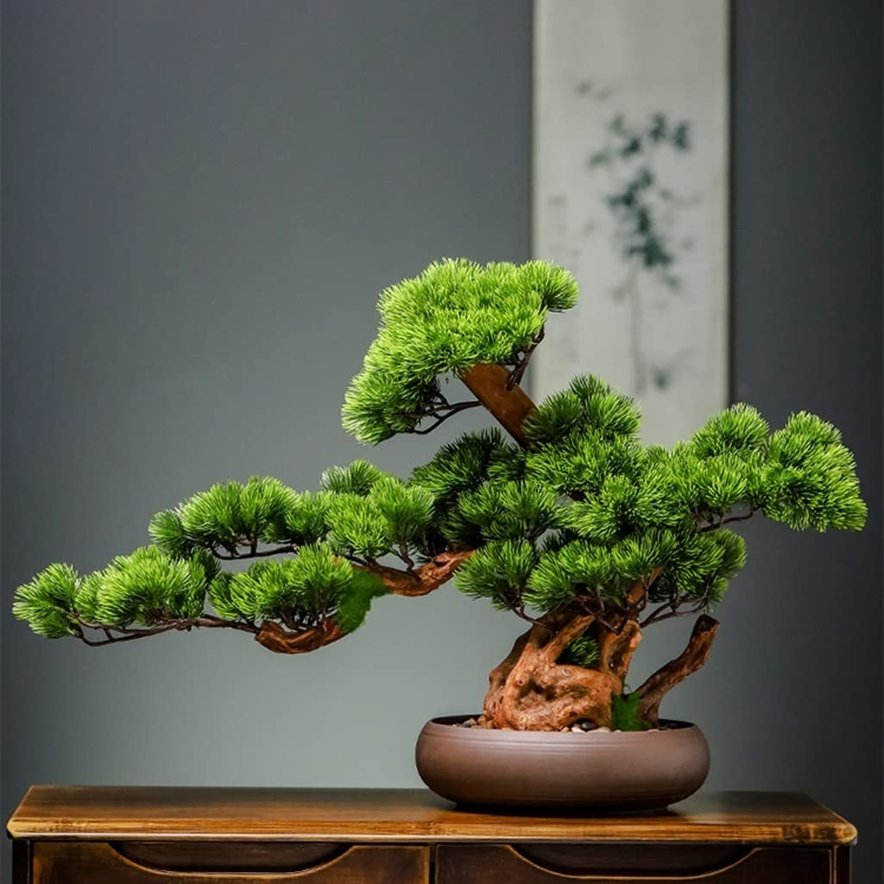

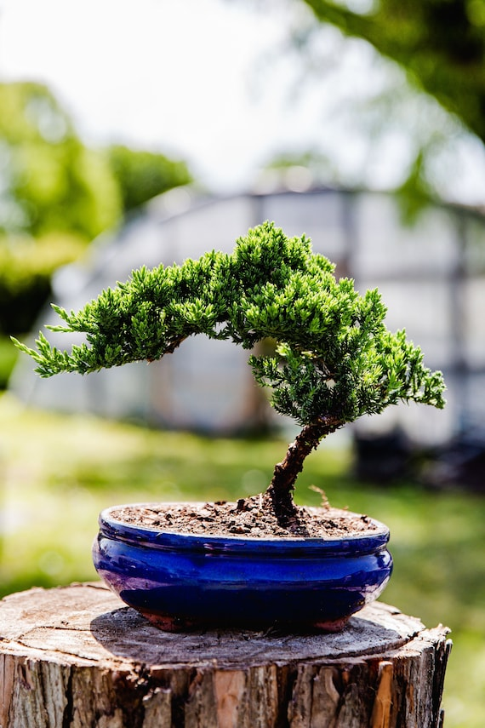

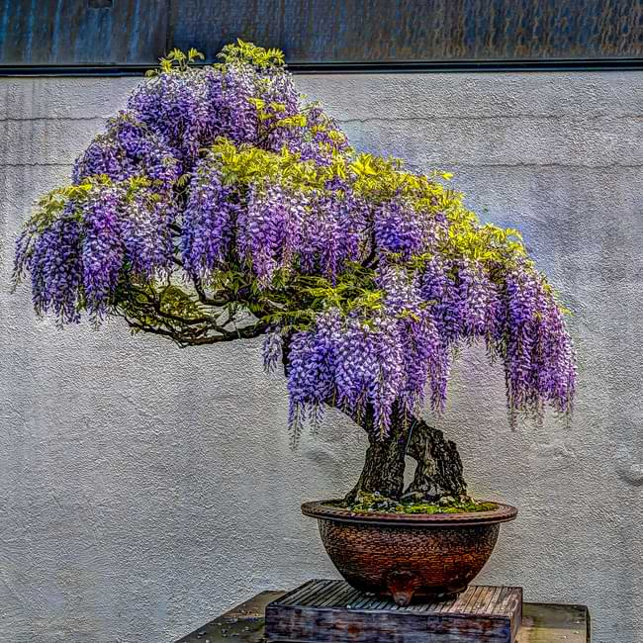

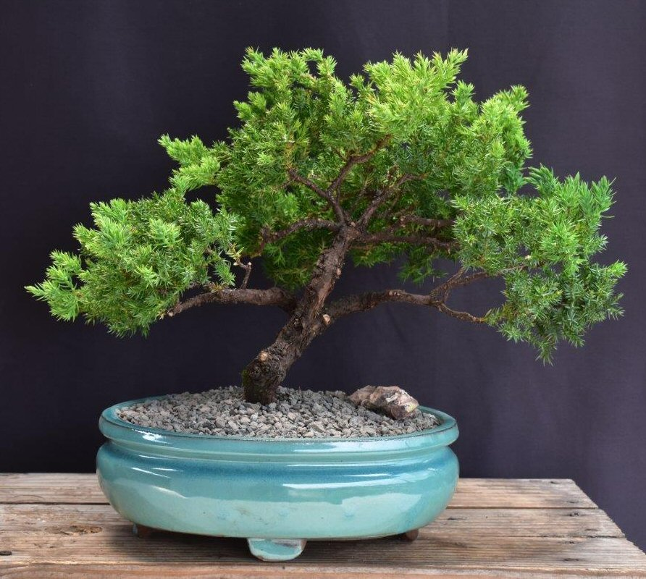

**Bonsai Basics**

Formal Upright

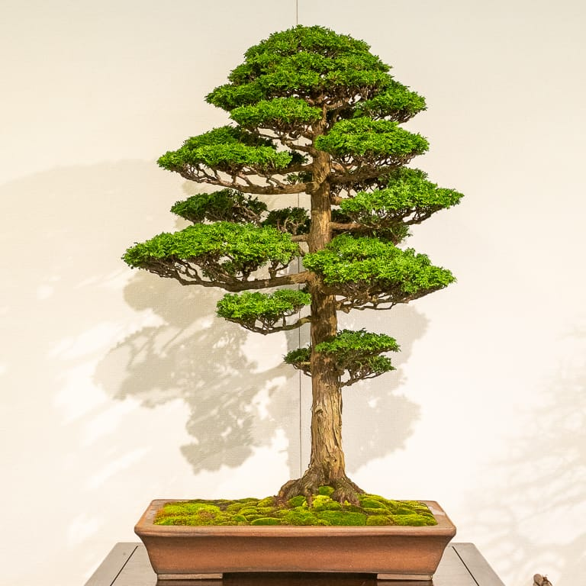

Informal Upright

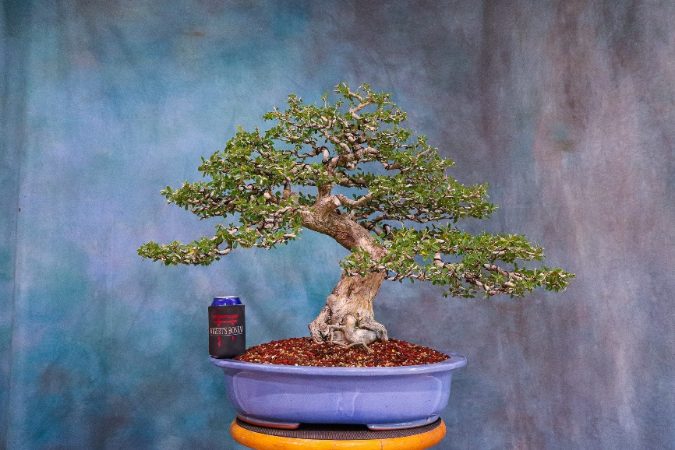

Slanted

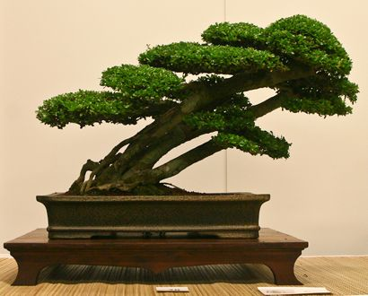

Semi-Cascade

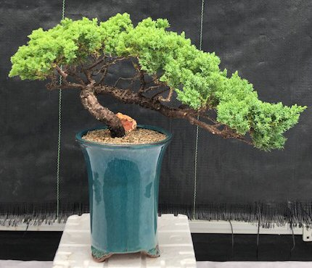

Full Cascade

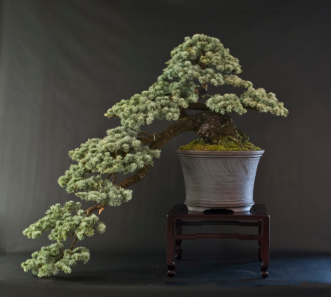

**Gallery**

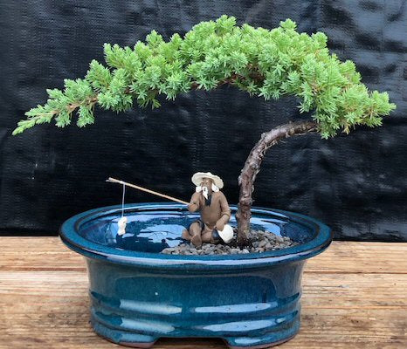

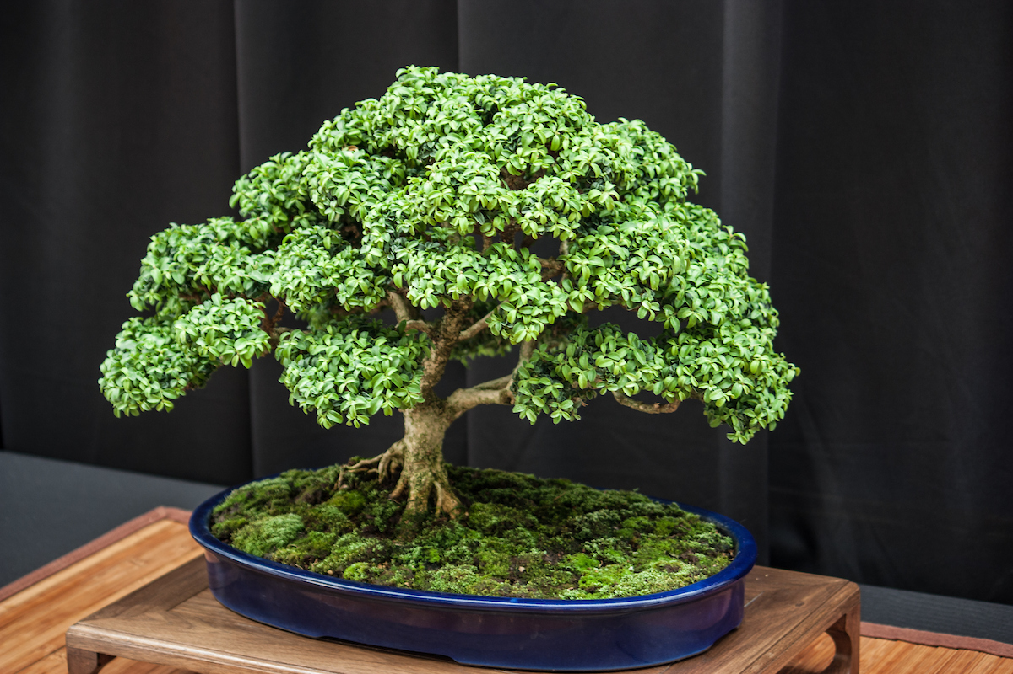

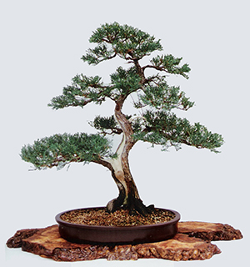

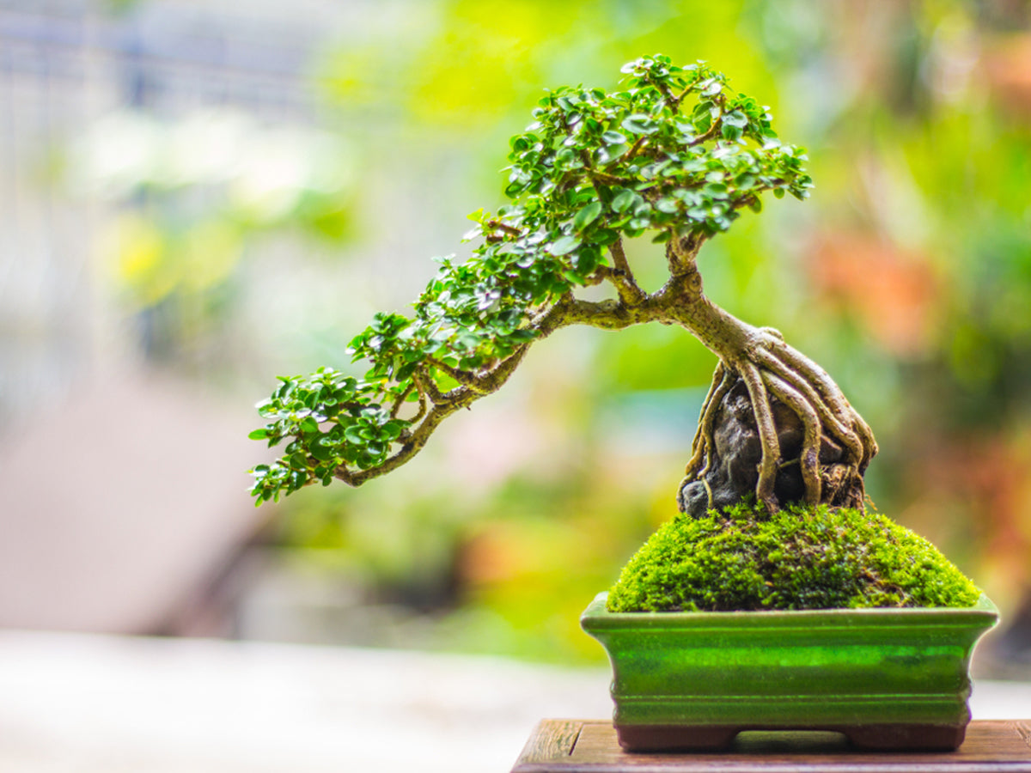

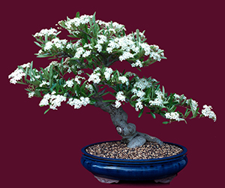

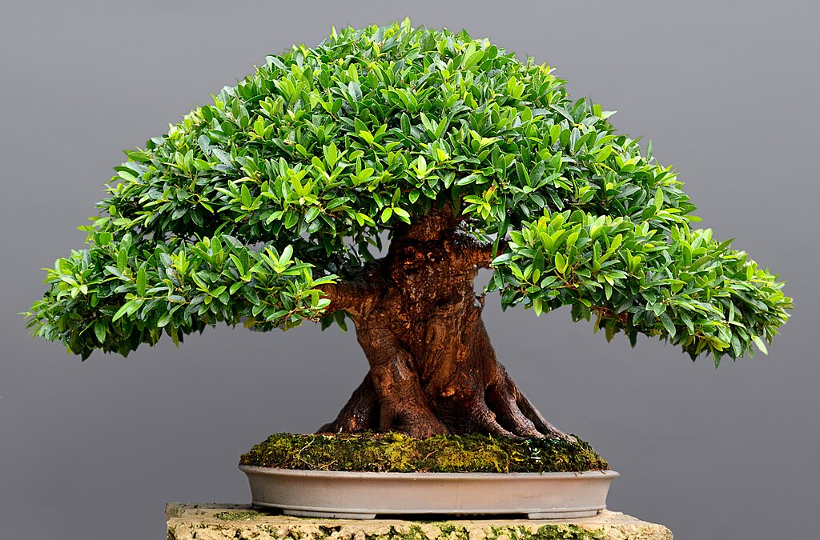

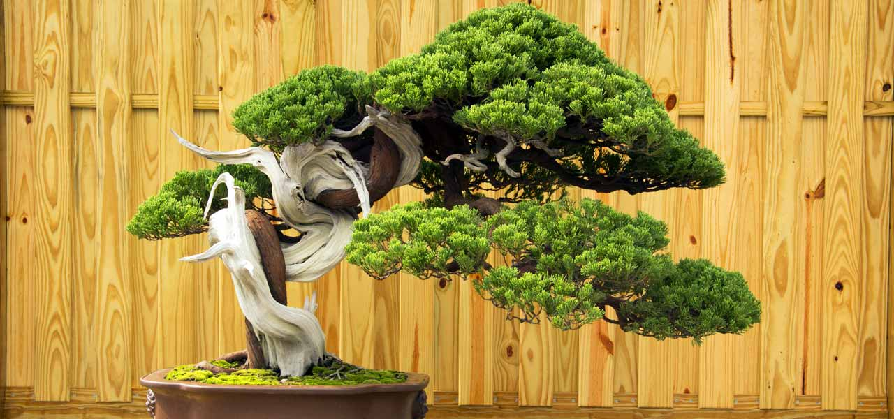

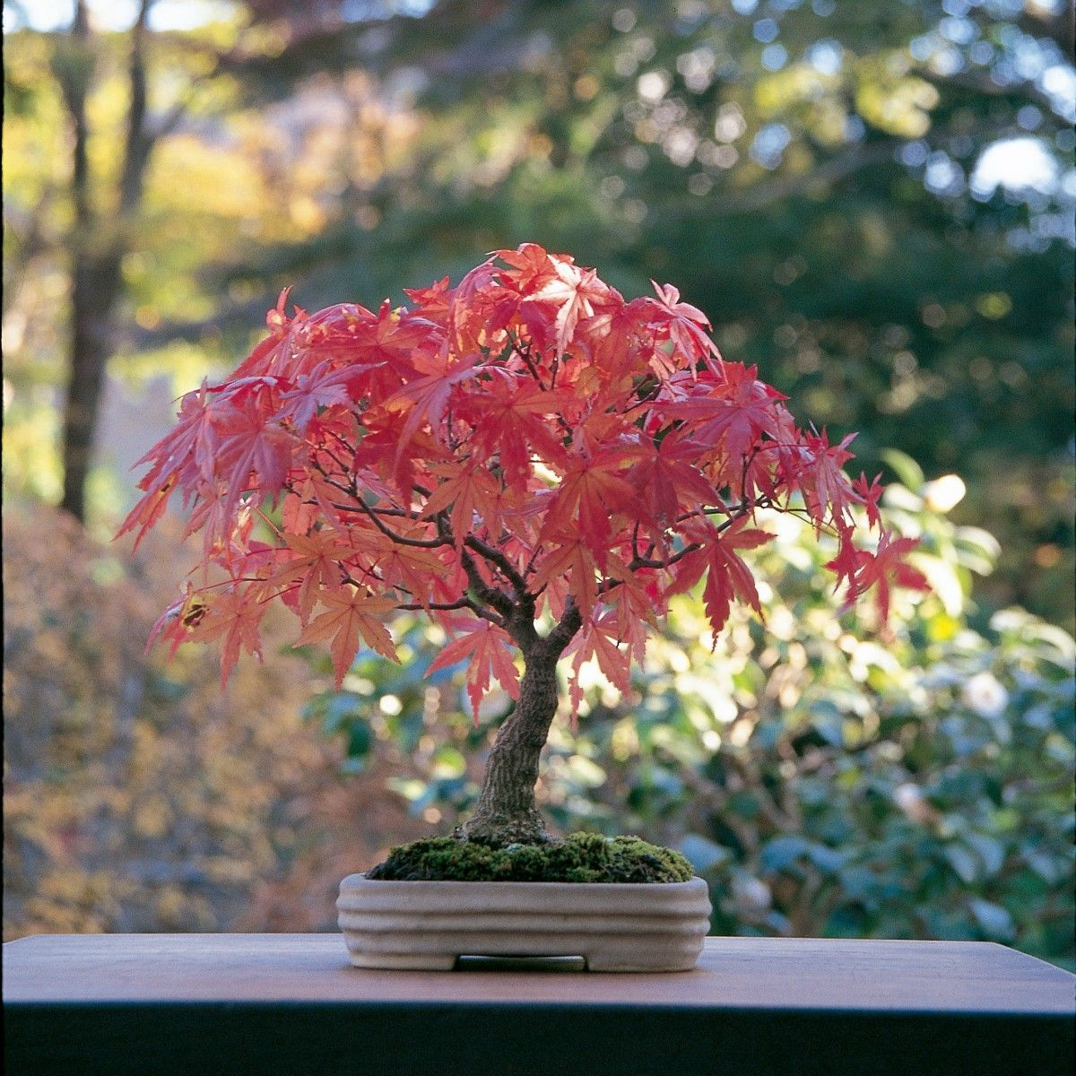

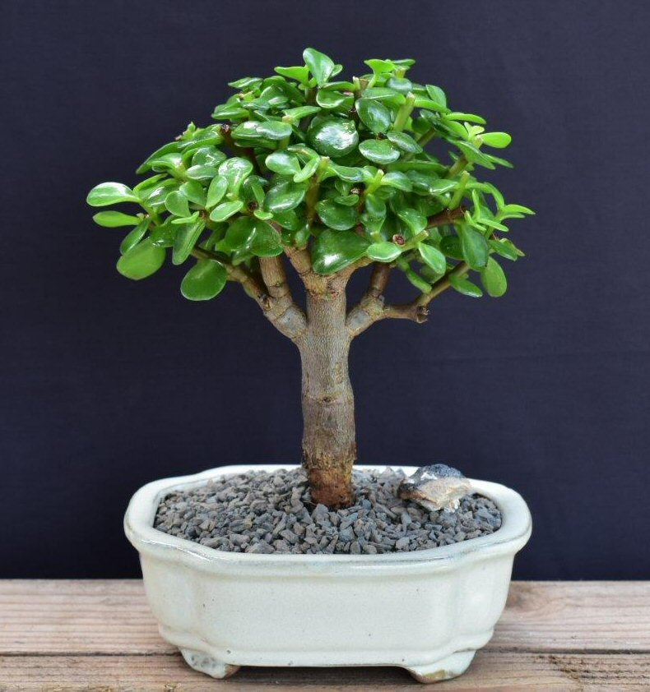

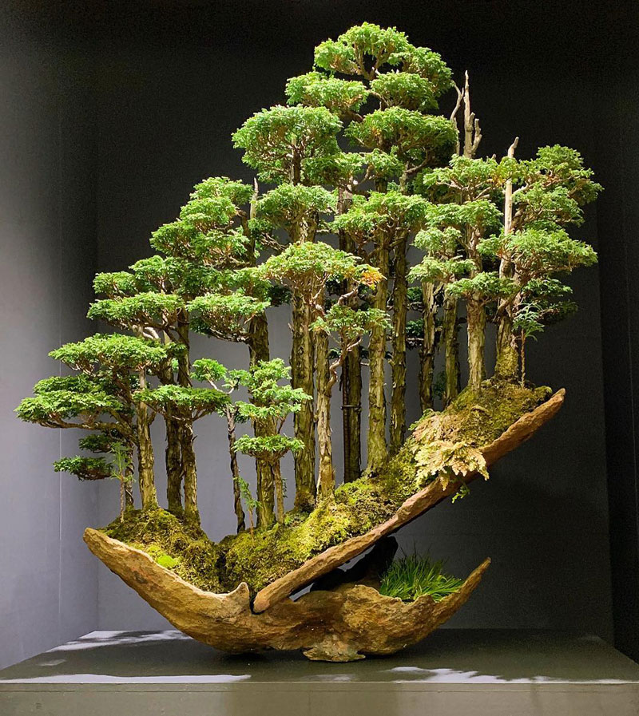

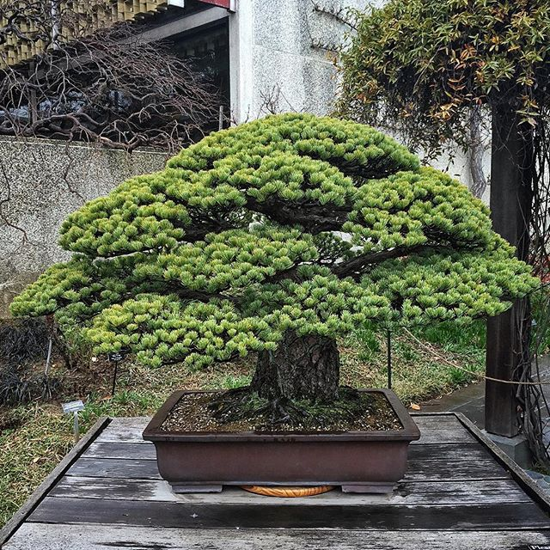

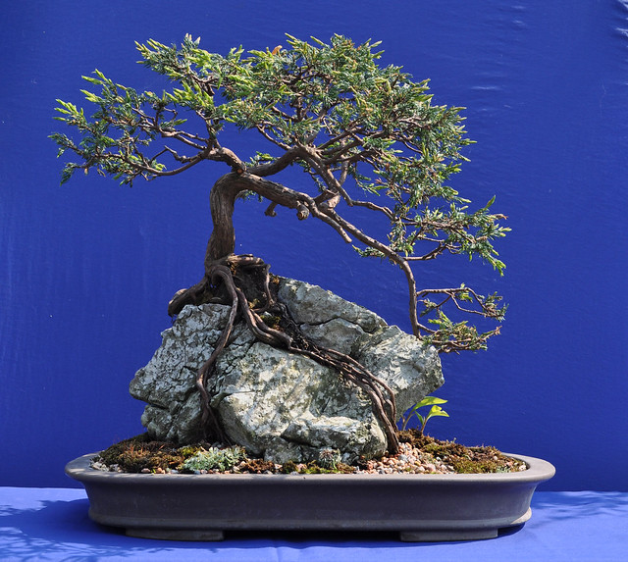

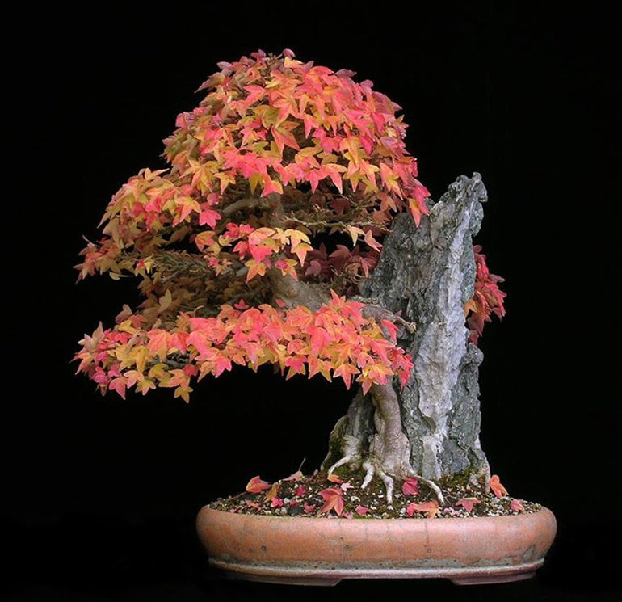

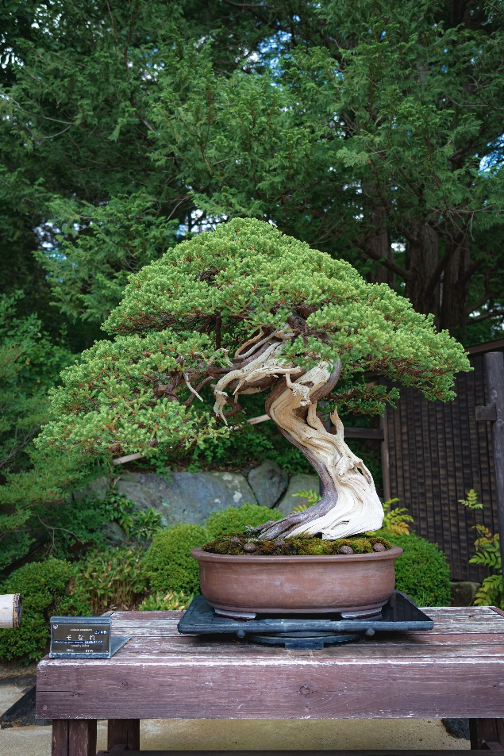

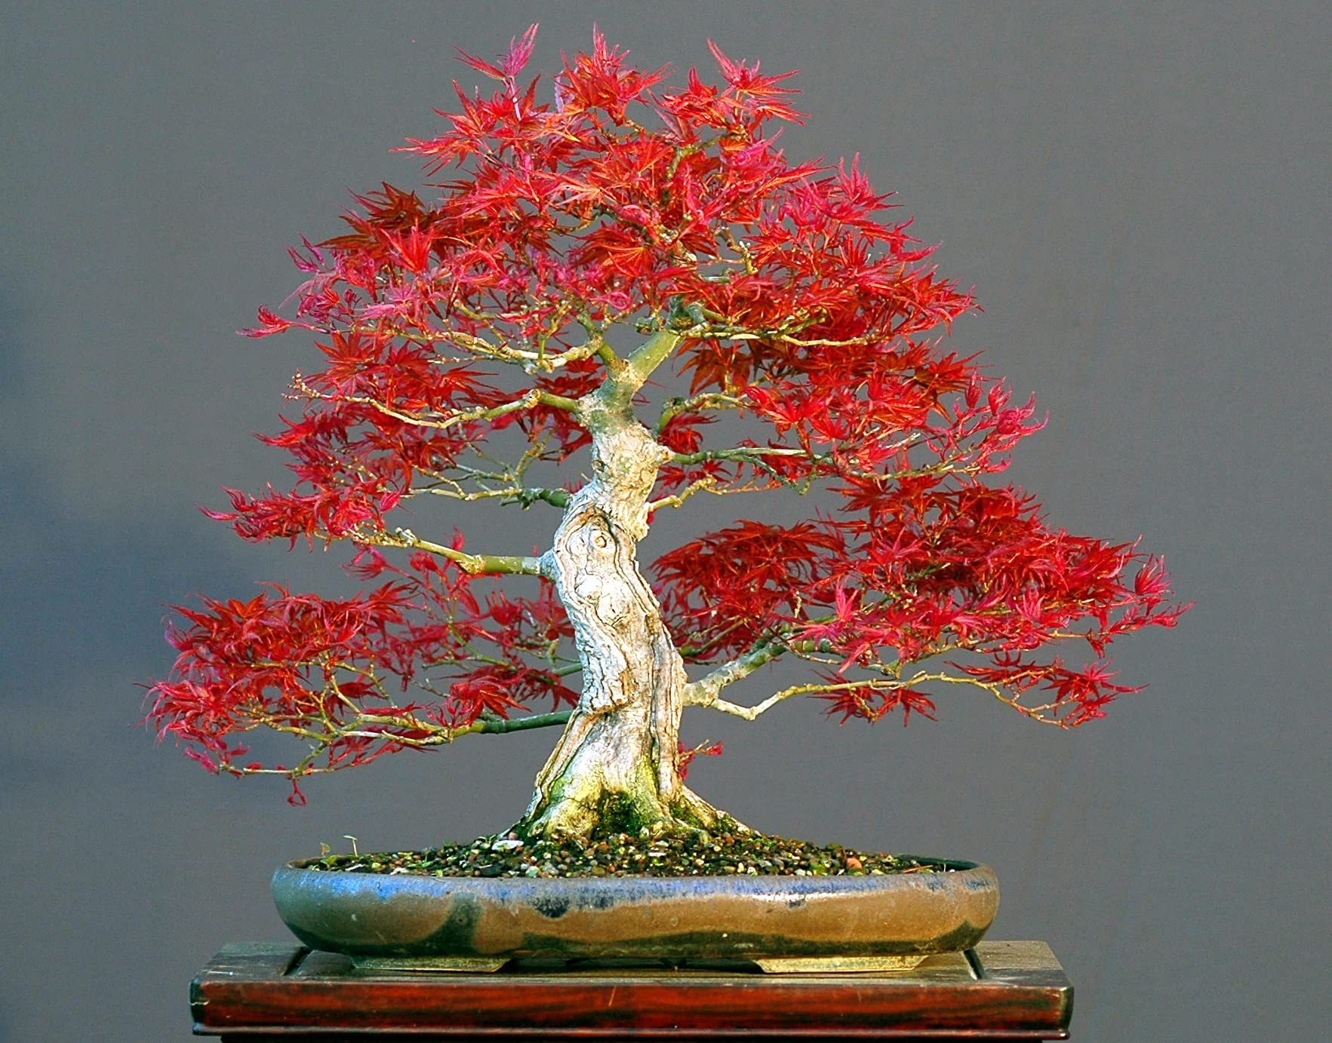

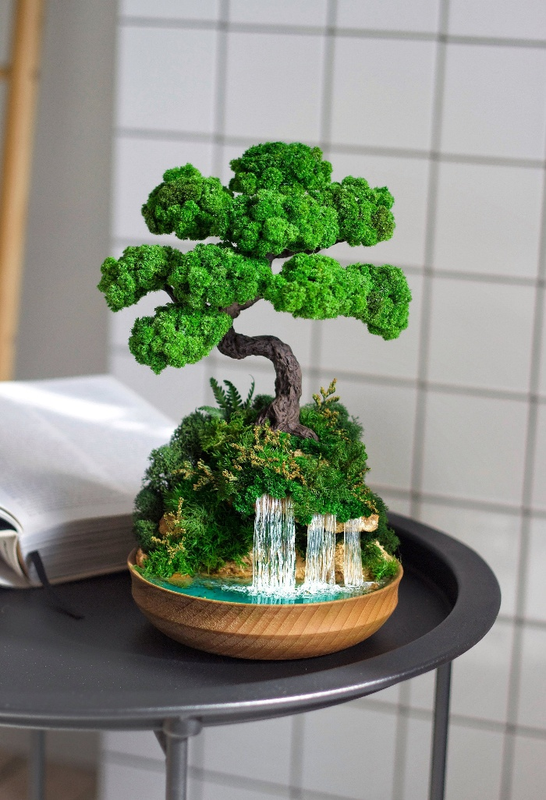

**Wireframes**

### Home

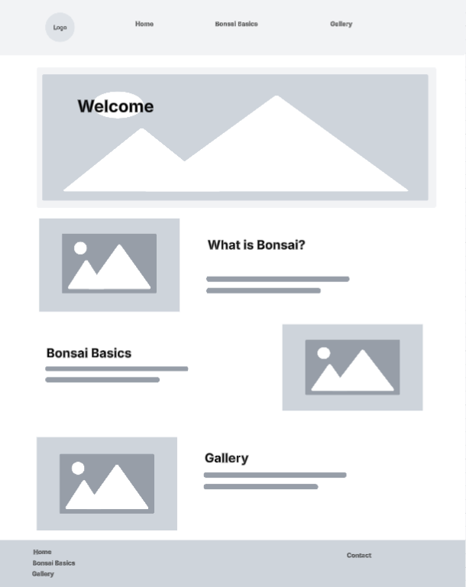

**Bonsai Basics**

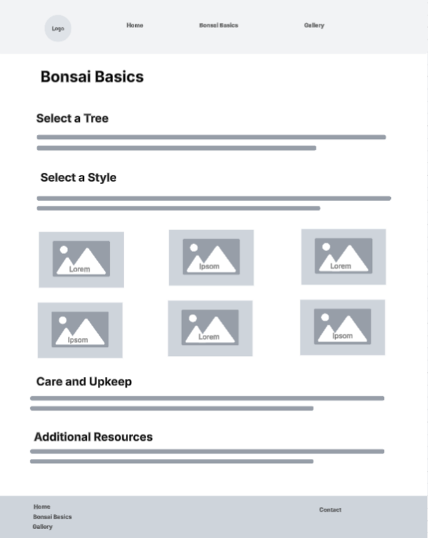

**Gallery**

